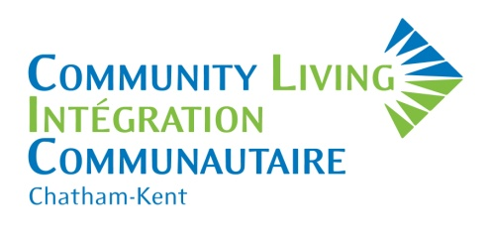
Becoming a member of Community Living Chatham-Kent matters! It keeps you connected and informed; it gives you a voice and makes you a part of a group with the shared goal of improving the lives of people who have diverse abilities.

Other membership benefits include:

- Voting rights for the Board of Directors at our Annual General Meeting.
- Eligible to serve on the Board of Directors or its committees.
- Opportunity to become better informed on issues that affect people who have diverse abilities.

We invite you to visit www.clc-k.ca and subscribe to our mail list to receive our Community Connections Newsletter to learn more about Community Living Chatham-Kent.

JOIN or RENEW your membership and together, we can continue to make a difference!

MARK YOUR CALENDARS! Our Annual General Meeting will be held on June 25, 2024.

Membership year: April 1, 2024 – March 31, 2025

Please complete this application and return it with your payment. Cash or cheque payable to Community Living Chatham-Kent.

Community Living Chatham-Kent
PO Box 967
650 Riverview Drive, Unit 2
Chatham, Ontario N7M 5L3

Please check one: □ Individual Membership $10.00
□ Family Membership* $20.00 (two or more immediate family members)
□ Affiliate Membership $10.00 (non-voting member for staff/agencies)
*FOR VOTING PURPOSES, if family membership has been chosen, please indicate all the names of people this includes (must be over the age of eighteen and residing at your address).
Name (s):______________________________________________________________________________
If you are a new member, or if the label on the mailing envelope is incorrect, please complete the box below.
Name:
Address/PO Box:
City/Town/Village: Postal Code:
Phone: Email:

