APPAREL SALE 2016

We are offering a variety of items displaying the Community Living Chatham-Kent logo.

The apparel is available for men and women, and is offered in a range of sizes and colours.

All prices include applicable taxes.

Simply complete the order form and submit it with your payment.

We have samples in a variety of sizes for people to try. It is encouraged to try on the apparel as fit may not be true to size.

We are hosting the following dates/times for you to see and try on the apparel at 101 Stewart Street

November 15 4:00 pm – 6:00 pm
November 21 4:00 pm – 6:00 pm
November 23 4:00 pm – 6:00 pm

Payment will be accepted on these dates.

Dates don’t work for you? No problem! Just give us a call at 519-352-1174 ext. 232 to set a time.

Community Living T-Shirts

The Women’s t-shirts are Fruit of the Loom Cotton V-Neck. (100% high density cotton preshrunk jersey)

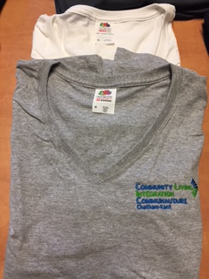

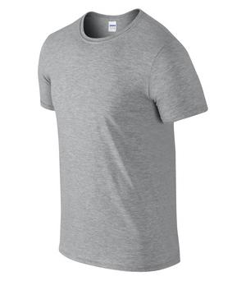
The Men’s t-shirts are Gildan™Ultra Cotton (100% (cotton preshrunk jersey)

T-shirts | Men | Women
Item Code | 2000 | L39VR
price | $15 | $15
sizes | S-5XL | S-2XL
colours | Sport Grey | White
 | Navy | Sport Grey Heather

It is encouraged to try on the apparel as fit may not be true to size.

Community Living Sports Shirts

The sports shirts are made by Coal Harbour and are 100% Polyester flat tricot micro piqué knit. They are a solid colour with a no-curl, rib knit collar (men’s), and a self-fabric collar (women’s). Both are moisture wicking and snag resistant.
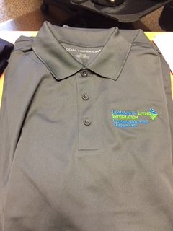

Golf Shirt | Men | Women
Item Code | S445 | L445
price | $30 | $30
sizes | XS - 6XL | XS - 4XL
colours | Iron Grey | White
 | True Navy | True Navy

It is encouraged to try on the apparel as fit may not be true to size.

Community Living Jackets

The Pro Team Jackets are made by ATC. The jackets are wind and water resistant and are made with 100% polyester with PU coating each with front welt pockets. The men’s jacket has elastic cuffs with hem and women’s has spandex binding cuffs and hem. The women’s jacket includes a 3-panel hood with self-fabric drawstring.

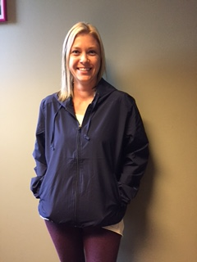

Jacket | Men | Women
Item Code | J780 | L780
price | $40 | $40
sizes | XS - 4XL | XS - 4XL
colours | True Navy | True Navy

It is encouraged to try on the apparel as fit may not be true to size.

Community Living Chatham-Kent Apparel Order Form

Please print, complete and mail/drop off with payment to Community Living Chatham-Kent c/o Angie.

Community Living Chatham-Kent Apparel Order Form
Name:
Location:
Item code | colour | size | price | quantity | total
 |  |  |  | TOTAL:
Payment terms: cash or cheque payable to "Community Living Chatham-Kent"
All orders must be paid for at time of ordering. All prices include applicable taxes.
Please complete the form and forward with payment to Community Relations c/o Angie. |  |  |  |  | Code: 1200-14

