CLC-K Presents the 4th Annual
Jonathan Daniel Stone Fund Awards

Community Living Chatham-Kent is pleased to announce the recipients of the Jonathan Daniel Stone Fund. Each recipient received a $1000.00 award to assist with the achievement of their initiative. The awards were presented on Thursday, December 14 at Community Living Chatham-Kent.

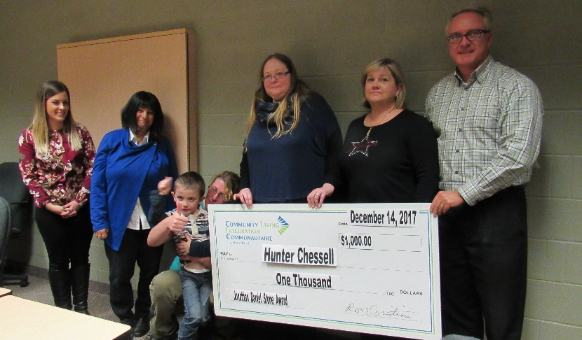
Hunter Chessell, a 5 year old boy who regularly utilizes the Children's Respite Program with Community Living Chatham-Kent lives with his mother and an older brother. The assistance of an iPad, along with corresponding communication software will enable Hunter to initiate communication, and he will gain satisfaction with his ability to successfully communicate with others.

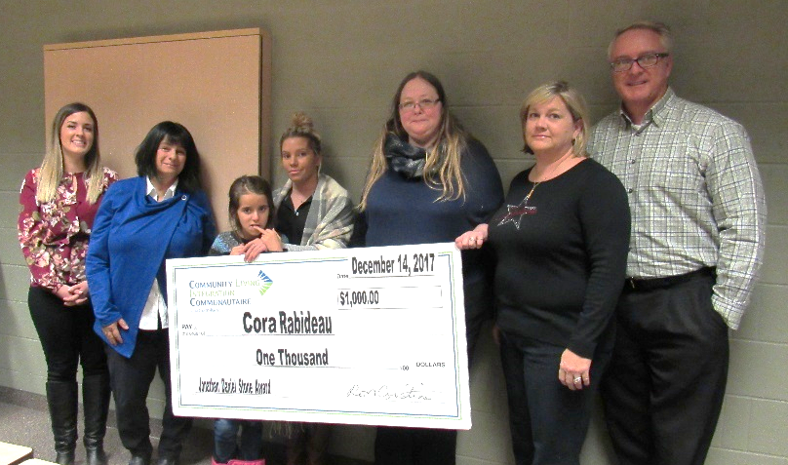
The second grant was awarded to Cora Rabideau. Coria is 9 years of age and also utilizes the Children's Respite Program with Community Living Chatham-Kent. Cora lives with her mother, grandmother and her younger brother. The purchase of an iPad, along with corresponding communication software will enable Cora to initiate communication while out in the community. This will be a great asset for the family while engaging in community activities.
This fund created by Jonathan Daniel Stone’s family, celebrates his life. Daniel was a child who had autism and died suddenly at the age of 11 in May of 2013. The purpose of the fund is to annually support initiatives to assist children and their families who have been diagnosed with autism and/or other intellectual disabilities. Daniel's fund can be utilized for but is not limited to: recreational activities, educational workshops for parents and siblings, advocacy, vocation and life skills development, assistive devices and equipment that promote and facilitate learning or communication. The recipients were selected by a review committee comprised of Dr. Jonathan and Sarah Stone, a person supported by Community Living Chatham-Kent, two Community Living Chatham-Kent Managers and a Community Living Chatham-Kent Board Member.

