CLC-K’S 24TH ANNUAL WALKATHON “7 WONDERS OF CANADA”
PARTICIPANT COUNT SHEET
 | SEPTEMBER 20 | SEPTEMBER 21 | SEPTEMBER 22 | SEPTEMBER 23 | SEPTEMBER 24 | SEPTEMBER 25
DESTINATION | TRAVEL TO NIAGARA FALLS |  | TRAVEL TO THUNDER BAY |  | TRAVEL TO BAY OF FUNDY, NB
# STEPS WALKED

 | SEPTEMBER 26 | SEPTEMBER 27 | SEPTEMBER 28 | SEPTEMBER 29 | SEPTEMBER 30 | OCTOBER  1
DESTINATION | TRAVEL TO CABOT TRAIL, NS |  | TRAVEL TO NWT AND NAHANNI PARK |  | TRAVEL TO ALB. & BC.  “ROCKIES” | RETURN TO CHATHAM
# STEPS WALKED
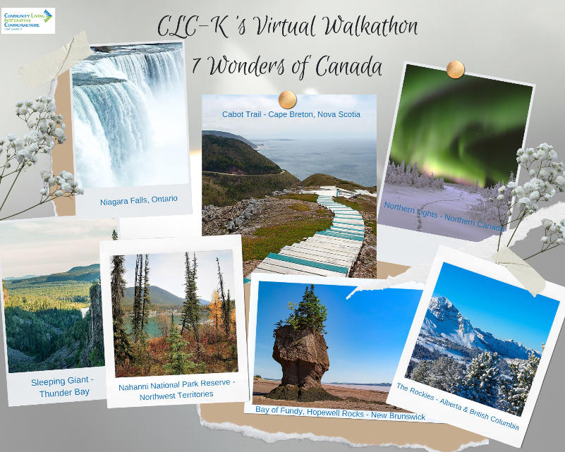
TOTALS:
Steps from Chatham to Niagara Falls: _____________
Steps from Niagara Falls to Thunder Bay: _____________
Steps from Thunder Bay to Bay of Fundy: _____________
Steps from Bay of Fundy to Cabot Trail: _____________
Steps from Cabot Trail to NWT: _____________
Steps from NWT to ALB. & BC: _____________
Steps from ALB. & B.C. to Chatham: _____________
TOTAL STEPS WALKED _____________

NAME: __________________________________________________

