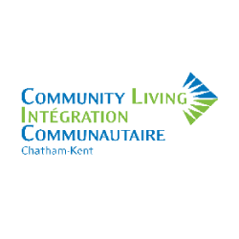
Community Living Chatham-Kent provides support and services for people who have an intellectual disability. Our goal is that all people live in a state of dignity, share in all elements of living in the community and have the opportunity to participate effectively.

Part-Time Direct Support Professionals

A career here allows you to:
- connect to a purpose
- help others
- make a contribution
- see meaning in your work
- have an impact on people and your community
- have a career that matters
- make a difference

Qualifications
A minimum of a high school diploma is required and preference shall be given to applicants who have a D.S.W. diploma or an acceptable combination of education, training and experience. Knowledge of health care procedures, and personal support skills are an asset. Valid CPR/First Aid and a current vulnerable sector check are required.
Hours of Work: Average 16-24 hours per week
Salary: $ 20.84 to $21.95 per hour
Qualified applicants are invited to e-mail, fax, or mail their cover letters and résumés. Community Living Chatham-Kent embraces a culture of diversity and inclusion, and welcomes applications from all qualified persons. Physical accommodations required during the hiring process will be made upon request.
Apply to hallison@clc-k.ca or fax 519-352-5459.
Please contact the Human Resources Administrator at 519.352.1174, extension 237 for additional information.

