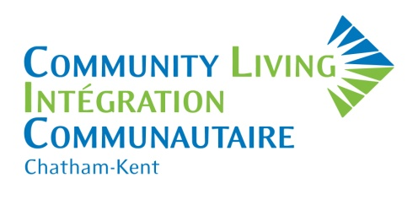
Becoming a member of Community Living Chatham-Kent matters! It keeps you connected and informed; it gives you a voice and makes you a part of a group with the shared goal of improving the life of people who have an intellectual disability.

Other membership benefits include:

- Voting rights for the Board of Directors at our Annual General Meeting
- Eligible to serve on the Board of Directors or its committees
- Opportunity to become better informed on issues that affect people who have an intellectual disability

We invite you to visit www.clc-k.ca and subscribe to our mail list to receive our Community Connections Newsletter and learn more about Community Living Chatham-Kent.

RENEW your membership and together, we can continue to make a difference!

MARK YOUR CALENDARS! Our Annual General Meeting will be held on June 18, 2019.

2019-2020 Single or Family Membership Fee: $10.00
Membership year: April 1, 2019 – March 31, 2020
Memberships are due by April 30, 2019

Please complete this application and return it with $10 cash or cheque payable to Community Living Chatham-Kent:
Community Living Chatham-Kent
PO Box 967
650 Riverview Drive, Unit 2
Chatham, Ontario N7M 5L3

Please check one: Single Membership □ Family Membership* □
*FOR VOTING PURPOSES, if family membership has been chosen, please indicate the names of people this includes (must be over the age of eighteen and residing at your address).
Name (s):_______________________________________________________________________________
Is a member of your immediate family employed by Community Living Chatham-Kent?
Yes □ No □
If you are a new member, or if the label on the mailing envelope is incorrect, please complete the box below.
Name:
Address/PO Box:
City/Town/Village: Postal Code:
Home Phone: Business Phone:
Email:

