CLC-K Presents the 6th Annual Jonathan Daniel Stone Fund Awards

Community Living Chatham-Kent is pleased to announce the recipients of the Jonathan Daniel Stone Fund. Each recipient received a $1,500.00 award to assist with the achievement of his or her initiative.
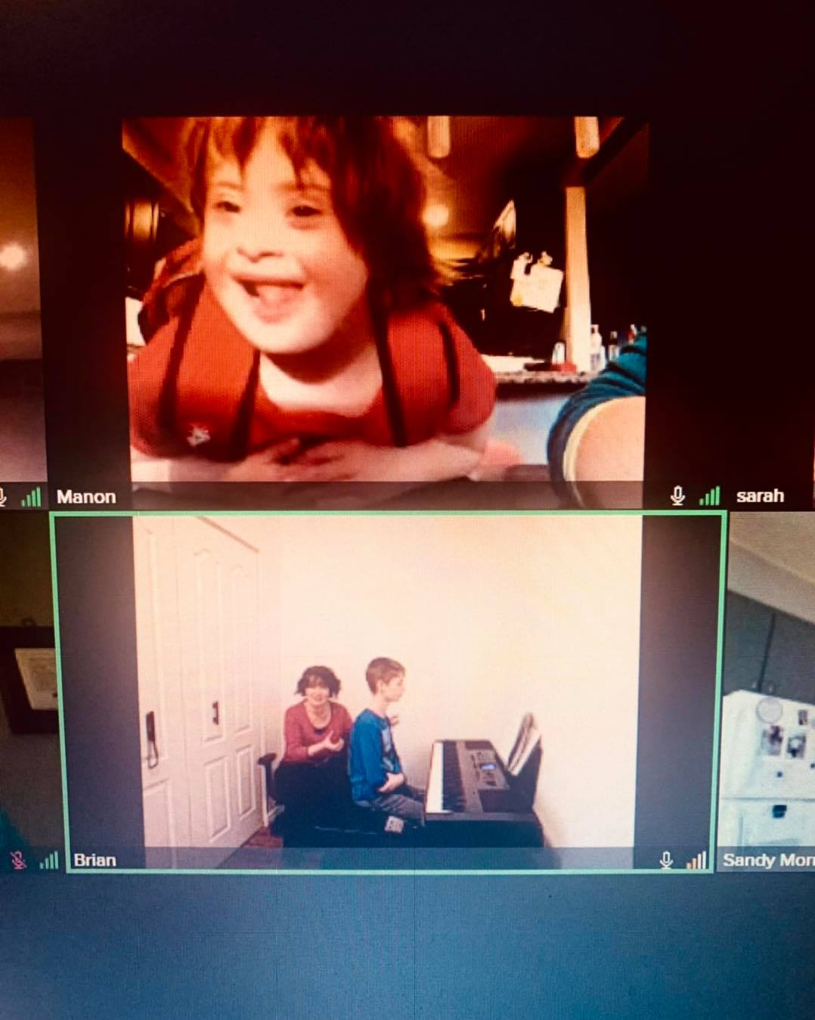
The awards were presented on Thursday, December 13 at Community Living Chatham-Kent.
The first Jonathan Daniel Stone Fund Award was presented to Manon Parisien-Robert. Manon is an 8-year-old girl who is loved by everyone she meets. She has requested a developmental trike. Riding the trike will increase her overall strength, and promote independence. Having this trike will give her a new outdoor activity and introduce her to road/sidewalk safety.
The Jonathan Daniel Stone Fund will be assisting Manon with purchasing this trike. We are planning to purchase this locally from Smith Cycle (Chatham).
The second grant was awarded to Liam Welford. Liam is an 11-year-old young man who is very musically inclined and currently plays the piano. He has requested a drum set and lessons which will increase his confidence, his range of musical ability as well as hand-eye coordination. Liam would love to volunteer at future fundraisers and community events, which could also help him socially.

The Jonathan Daniel Stone Fund will be assisting Liam to pursue this love with purchasing a full 8-piece drum kit and drum lessons! Congratulations Liam!

This fund created by Jonathan Daniel Stone’s family, celebrates his life. Daniel was a child who had autism and died suddenly at the age of 11 in May of 2013. The purpose of the fund is to annually support initiatives to assist children who have been diagnosed with autism and/or diverse abilities. Daniel's fund can be utilized for but is not limited to recreational activities, educational workshops for parents and siblings, advocacy, vocation and life skills development, assistive devices and equipment that promote and facilitate learning or communication. The recipients were selected by a review committee comprised of Dr. Jonathan and Sarah Stone, a person supported by Community Living Chatham-Kent, two Community Living Chatham-Kent Managers, and a Community Living Chatham-Kent Past Board Member.

