DAY PROGRAM

COMFORT CAMPAIGN

Many of the people supported by Community Living Chatham-Kent are active and vibrant contributing citizens within the community. The Park Avenue Day program is a welcomed space for many to learn new skills, and socialize. Your donation will help buy essential furniture and tools to meet their physical and safety needs, as well as support their personal and emotional comfort. It’s just one of the ways we care.
Campaign priorities include:

Quiet Spaces for Visits
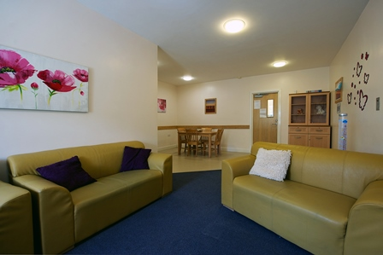
Finding a quiet space in a busy day program is an opportunity for friendship and reflection. At the Park Avenue Day Program, space is available for quiet conversations, reading or listening to music. Donors can help refresh the space and make it more welcoming with new furniture, such as couches, coffee tables, and end tables. A fresh coat of paint and repairs to walls, as well as other decorative touches (pictures, plants, and lamps), will help to renew this welcomed space.

Patio Furniture, Fresh Air and Sunshine
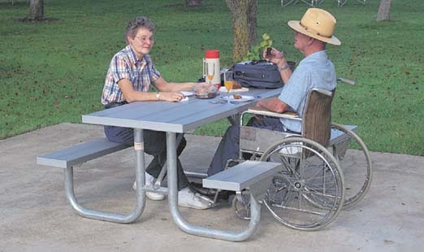
Being outdoors is therapeutic for everyone. Your donation to enhance an outdoor patio space at the Park Avenue Day Program will have a positive impact on lives of people who wish to take part in social activities outdoors, or spend peaceful moments in a natural garden setting. Your donation will assist to purchase picnic tables, benches, and garden planters.
Your donation today will make the difference in the lives of people utilizing the Park Avenue Day Program.
For more information about the Comfort Campaign, contact Angela Corso, Manager of Community Relations at 519-352-1174 ext. 232.

