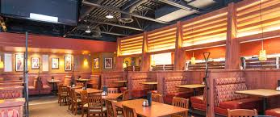
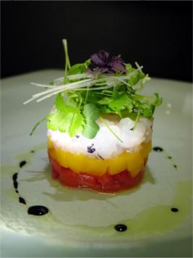
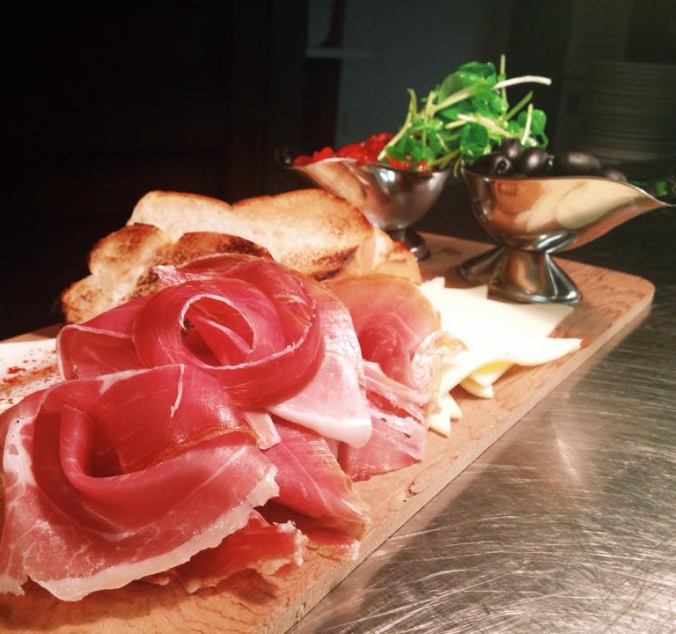
All proceeds to provide support and services to over 550 people who have an intellectual disability in Chatham-Kent.
Sponsorship Opportunity Package
2017
2017 FOOD CRAWL
Thursday, July 20

Community Living Chatham-Kent is thrilled to present the 2nd Annual Food Crawl which will feature different menu items from various restaurants in Chatham-Kent. The night will be a fantastic opportunity to try new appetizers, mingle with a group of friends, and celebrate summer!

Participating Restaurants include:

Boston Pizza Chilled Cork Restaurant & Lounge
Frendz Tapas Martini Lounge Chatham Bowlerama
Chatham’s Breakfast House and Grille Churrascaria

The experience will expose up to 184 participants to venues and food items without demanding a big commitment of time. Buses will rotate across Chatham-Kent, taking participants to different restaurants between 6:00 pm - 9:30 pm, where they will have approximately 35 minutes at each restaurant.

We are requesting sponsorship to offset costs in order to make the best possible experience for all participants. Proceeds are used to provide support and services to over 550 people who have an intellectual disability and their families in Chatham-Kent.

Thank you for your thoughtful consideration. Attached are details for each level of sponsorship. We are available to assist you in selecting your sponsorship opportunity and answer any questions you may have.

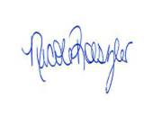
Yours truly,
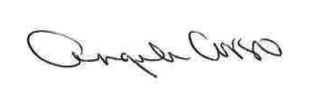

Angela Corso Nicole Roeszler
Manager of Community Relations Supervisor of Events and Volunteers
519-352-1174 ext. 232 519-352-1174 ext. 231
acorso@clc-k.ca nroeszler@clc-k.ca
2017 FOOD CRAWL
Thursday, July 20

GOURMET SPONSOR - $2,000
(two sponsors accepted)

See GOURMET sponsorship package for this exciting opportunity!

RESTAURANT SPONSOR - $500
(five sponsors accepted)
- 2 tickets to Food Crawl – includes all food and transportation for participants
- Choice of themed bus for group! (pending availability)
- Business logo featured at one signature restaurant - table tent cards
- Live acknowledgement and appreciation at signature restaurant
- Logo and thankful acknowledgement featured on CLC-K website and social media

BUS SPONSOR - $200
(multiple sponsors accepted)
- Signage on all bus transportation (business logo)
- Multiple live acknowledgements though speaker system when traveling to restaurants
- Logo and thankful acknowledgement featured on CLC-K website and social media

I prefer to make a tax-deductible charitable donation of $_________________

Details: _______________________________________________________________

Food Crawl
2017 Sponsorship Information

SPONSORSHIP LEVEL: (Please check the appropriate box below.)
Gourmet Sponsor ($2000) Restaurant Sponsor ($500) Bus Sponsor ($200)
I am making a tax-deductible charitable donation (Amount: $ __________)

CONTACT NAME:_____________________________ TITLE: _______________________________

COMPANY NAME: ____________________________ EMAIL: ______________________________

- Acknowledge permission to receive correspondence via e-mail for fundraising and promotional purposes.

ADDRESS: ____________________________________________________________________________

CITY: ____________________ POSTAL CODE: _________________ PHONE#: ____________________

My cheque in the amount of $ ______________________ is enclosed.
Community Living Chatham-Kent
650 Riverview Drive, Unit 2
Chatham, ON N7M 5L3

Cheque payable to Community Living Chatham-Kent and mail to:

Please charge my VISA/MasterCard # ________-________-_________-_________ CV #: _____

Expiry Date: ________/________ Name on Card: ________________________________

Signature: _______________________________________________________________

CANADA REVENUE AGENCY DEFINITIONS:
SPONSORSHIP - when a business makes a donation to a charity and in return, receives advertising or promotion of its brand, products or services. As per Canada Revenue Agency (Policy CSP-S13), charitable tax receipts cannot be issued for sponsorships as they are not considered gifts. Community Living Chatham-Kent cannot issue a donation receipt where a corporation/business receives a material advantage such as promotion or advertising in return, BUT the corporation can claim the contribution as an advertising expense when provided with a business receipt from Community Living Chatham-Kent.

GIFT – a voluntary transfer of property without expectation of return or considerations. To this end, charitable gifts are welcome and donors will be issued a tax-deductible receipt, but will not receive sponsorship benefits as noted above.
ANY QUESTIONS?
Please contact Nicole Roeszler: 519-352-1174 ext.231, nroeszler@clc-k.ca

