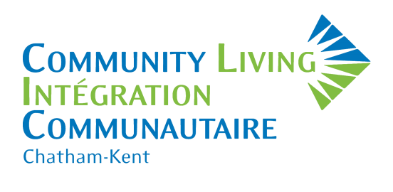
Count us in!
In support of people who have an intellectual disability in Chatham-Kent.
We are pleased to host our Annual Golf Tournament on Saturday, June 9, 2018 at Deer Run Golf Course, with proceeds to provide support and services to over 550 people who have an intellectual disability and reside in Chatham-Kent.

Our tournament provides sponsors with a fantastic opportunity to promote your business in a meaningful way that will help you reach your social-responsibility marketing goals, by aligning your business with one of our community’s most trusted and long-standing agencies—Community Living Chatham-Kent!

In 2017 the golf tournament was SOLD OUT with 144 golfers, plus additional guests for dinner. We raised almost $20,000. Our goal for 2018 is to raise $25,000.

Thank you for your thoughtful consideration of this opportunity!
Sponsorship Opportunities
June 9, 2018
Deer Run Golf Course

Please complete BOTH SIDES of this sheet and return to:

Community Living Chatham-Kent
P.O. Box 967
650 Riverview Drive, Unit 2
Chatham, ON N7M 5L3
or email: info@clc-k.ca
- GOLD SPONSOR $ 750
- GOLF CART SPONSOR $ 300
- HOLE SPONSOR $ 200

OR

I prefer to make a tax-deductible charitable donation $___________ Details: _____________________________

RECOGNITION  LEVELS | WASTE CONNECTIONS OF CANADA  TITLE SPONSOR  $ 4,500 | GOLD SPONSOR  $ 750 | GOLF CART SPONSOR  $ 300 | HOLE SPONSOR  $ 200
Website Recognition
E-Newsletter acknowledgement
Name & Logo on Table Tent Cards
Logo on Carts
Signage on hole
Free registrations | 4 teams of 4 | 1 teams of 4
Sponsor Banner
Radio / Print Media
Reserved Dinner Seating
Deer Run Breakfast

Sponsorship Information

CONTACT NAME:_____________________________ TITLE: _______________________________

COMPANY NAME:____________________________ EMAIL: ______________________________

ADDRESS: ____________________________________________________________________________

CITY: ____________________ POSTAL CODE: _________________ PHONE#: ____________________

- Acknowledge permission to send correspondence via e-mail for fundraising and promotional purposes.

Sponsorship Level: _______________________________________

PAYMENT:

Credit Card Payment: In order to protect your credit card information, we will contact you by phone to complete your credit card information.

Cheque Payment: My cheque in the amount of $ ______________________ is enclosed.
Community Living Chatham-Kent
P.O. Box 967
650 Riverview Drive, Unit 2
Chatham, ON N7M 5L3
Cheque payable to Community Living Chatham-Kent and mail to:

CANADA REVENUE AGENCY DEFINITIONS:
SPONSORSHIP - when a business makes a donation to a charity and in return, receives advertising or promotion of its brand, products or services. As per Canada Revenue Agency (Policy CSP-S13), charitable tax receipts cannot be issued for sponsorships as they are not considered gifts. Community Living Chatham-Kent cannot issue a donation receipt where a corporation/business receives a material advantage such as promotion or advertising in return, BUT the corporation can claim the contribution as an advertising expense when provided with a business receipt from Community Living Chatham-Kent.

GIFT – a voluntary transfer of property without expectation of return or considerations. To this end, charitable gifts are welcome and donors will be issued a tax-deductible receipt, but will not receive sponsorship benefits as noted above

